Lab Guide

Fun with Indoor Mapping:  
MapWize - ServiceNow Integration

Lucas Fontanilla & Ramiro Rincón

Lab instance: http://clabs.link/ccw3963

Default Login / Password:

admin / Knowledge17

itil / Knowledge17

employee / Knowledge17

Lab Goal

Lab 1.1   
Create New Venue

For integrating our indoor map with ServiceNow, first we need to create a map in the MapWize tool and its elements like floors, places and defining routes.

# Log on to the mapwize admin page.

Navigate to the following URL <https://www.mapwize.io/admin> Log in credentials will be provided to you.Create New Venue

**Credentials Demo:**

**User:** mapwize_test@novoscale.com

**Password:** rTlh4*0qs

1. Navigate to **Create new venue**.  
     
   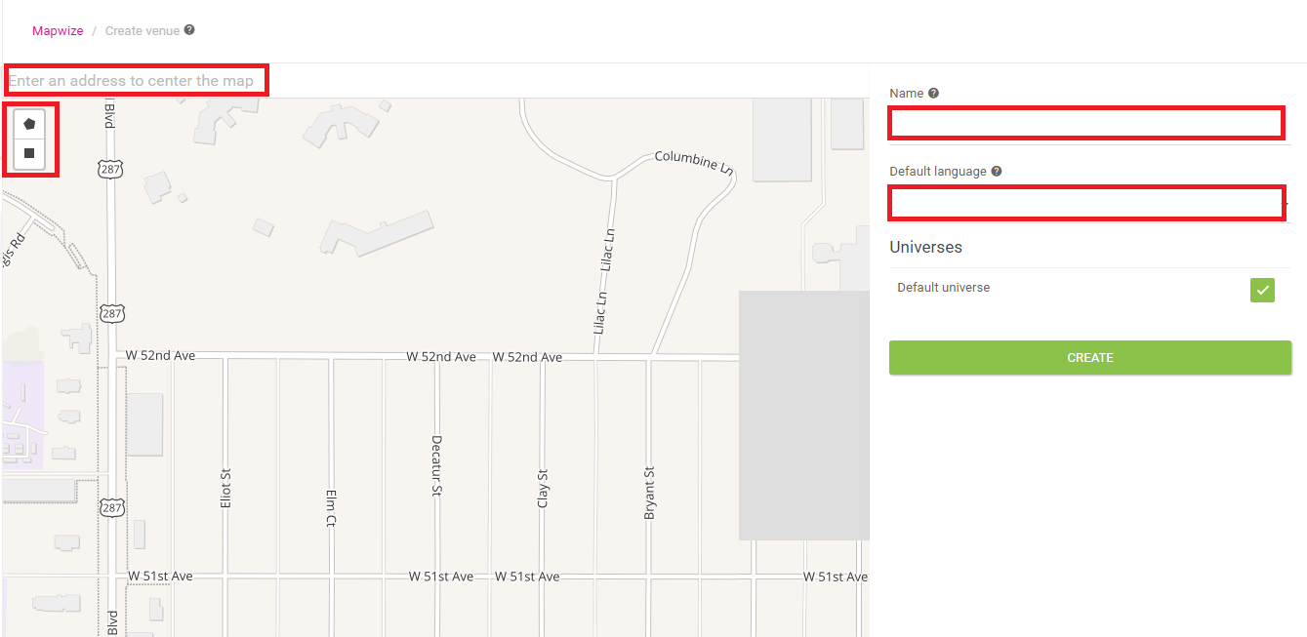

Fill in the form with the following information:

* Name: **Insert any name of your choice for the venue, make it significant.**
* Default Language: **English**
* You can select a map location by entering an address or you can drag the map with the mouse and use the mouse wheel for zooming in or out.
* Mark the perimeter of the venue using the **Polygon** or **Rectangle** tools.
* Hit the **CREATE** button.

# Create a Layer

1. Still in the MapWize admin page, navigate to **Layers**.
2. Navigate to **CREATE NEW.  
   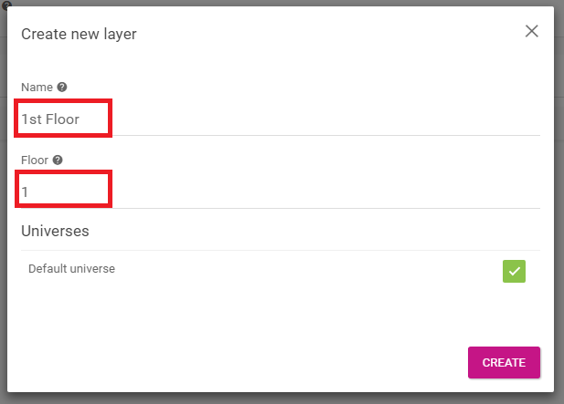**

Fill in the form as follows:

* Name: **Insert any name of your choice for the venue, make it significant.**
* Floor: **1**
* Hit the **CREATE** button.

# Import a map to your Layer

After the Layer is created you can import a map image that represents the floor, this is how the end user is going to see the map and locations in it.

1. Still in the MapWize admin page, navigate to **Layers**.
2. Select the **EDIT** button of the Layer created in the previous step.
3. Drag a PNG map file to the section **Drag and drop your plan as .png file here**

**Use this DEMO BluePrint:** <https://goo.gl/IDLNPd>

1. Use the Red Location markers to locate your map over the section selected in the Create Venue section. You can modify the transparency of the map with the Transparency slider on top.
2. When satisfied, hit the **IMPORT** button.
3. Activate check **Published.**
4. **Save**

The Layer should look something like this below: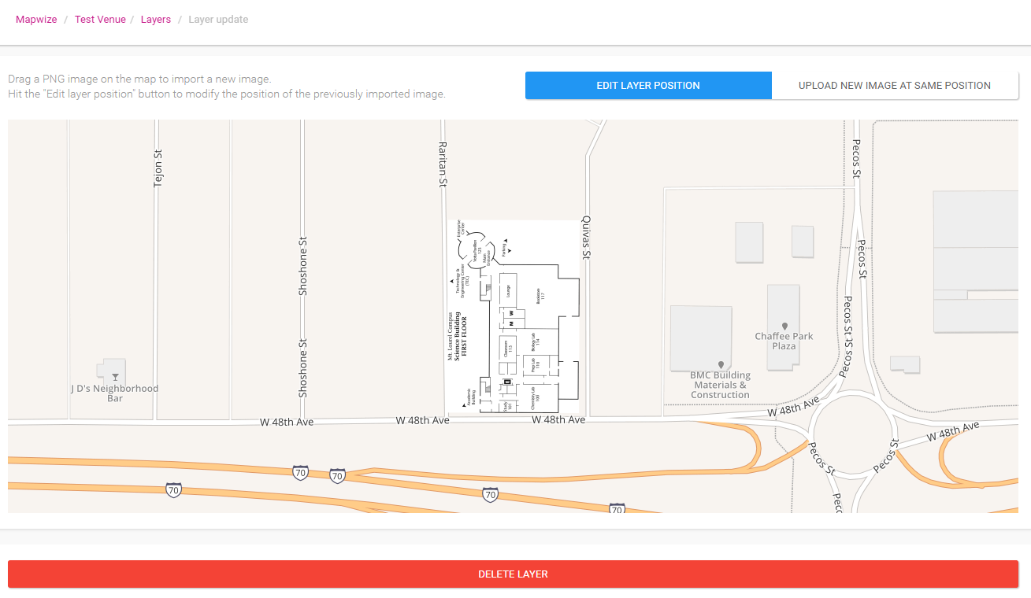

# Create Places

The next step is to create places in our map, those may be meeting rooms, assets, bathrooms, exits, stairs, kitchens, etc.

Let’s create 4 places, those are enough for us to see the functionality:

1. Still in the MapWize admin page, navigate to **Places**.
2. Select the **Draw a Marker** button in the top left of the map.
3. Select one location in the imported map that we will use to represent a real place in our map.

After selecting a location, the Place form will show, please fill in the form as follows:

* Name: **Insert any name of your choice for the place, make it significant.**
* The **Title** field will autofill.
* Floor: Select the Layer you created if not autoselected.
* Place type: There appears a comprehensive list of what the place we are creating can represent, please select one.
* Hit the **SAVE** button.

Repeat these steps 3 more times to create 3 other places around the map.

The Layer at the end should look something like this below:

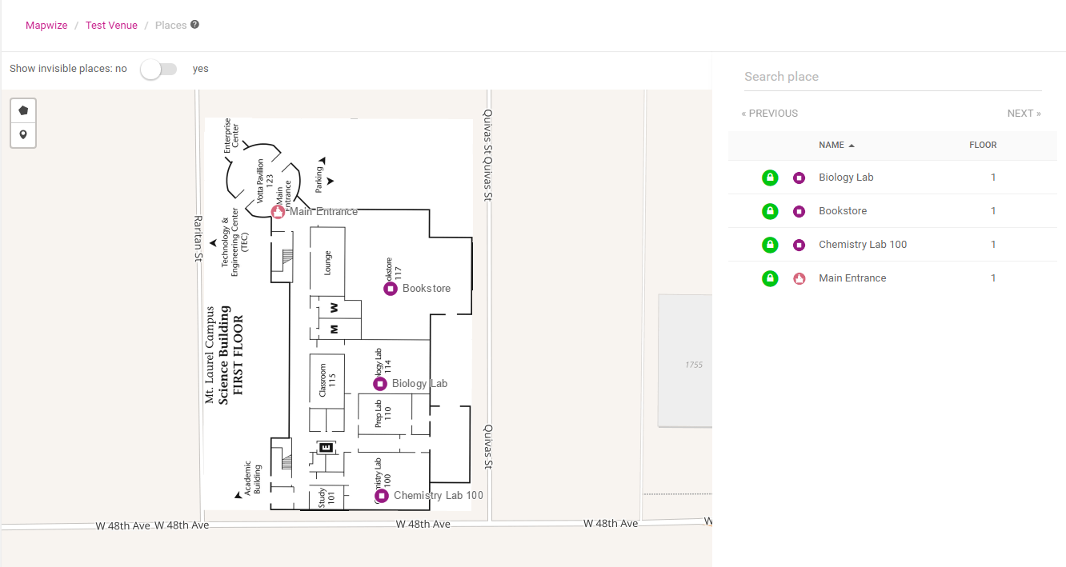

# Create Directions

The final step in the map side is to create directions between our places in the map.

We will create directions between the places already created:

1. Still in the MapWize admin page, navigate to **Directions**.
2. Hit the **CREATE NEW** green button in the top right of the map.
3. Switch to the DRAW tab, and connect all the places created with lines that would represent the actual path a person would take to go from one place to the other.
4. Hit the **SAVE DIRECTION** button.

The resulting map with directions should look something like this:

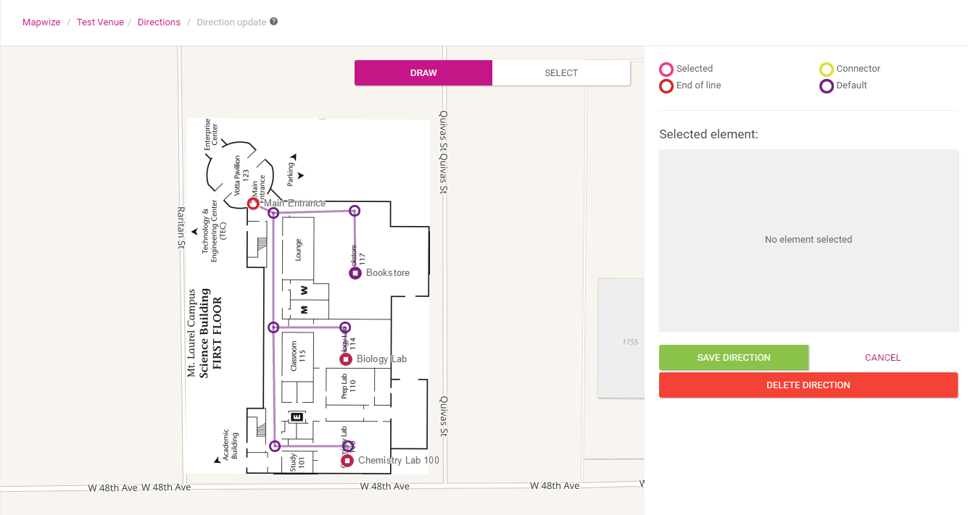

# 

# Setup development elements MapWize side

To get setup MapWize for ServiceNow integration we need to do 3 things:

* Create an Access Group
* Create an Access Key
* Create an API key/Application

# Create an Access Group

1. Go to the mapwize admin homepage and then enter the **Access Group** menu.
2. Hit the **CREATE NEW** green button in the top right of the map.
3. Fill in a **name**, please make it significant and make note of it.
4. Select the **venue** you created in the Access (Select a venue) field.
5. Hit the **CREATE** button.

# Your screen should look like this:

# Create an Access Key

1. Go to the mapwize admin homepage and then enter the **Access Key** menu.
2. Hit the **CREATE NEW** green button in the top right of the map.
3. Fill in a **name**, please make it significant and make note of it.
4. Select the **Access group** you created in the previous step in the Access (Access Group) field.
5. Hit the **GENERATE KEY** button. The Key field should autofill.
6. Hit the **CREATE** button.

# Your screen should look like this:

# 

# Create an Application

1. Go to the mapwize admin homepage and then enter the **Developers -> Applications** menu.
2. Hit the **CREATE NEW** green button in the top right of the screen.
3. Fill in a **name**, please make it significant and make note of it.
4. Hit the **CREATE** button.

# Your screen should look like this:

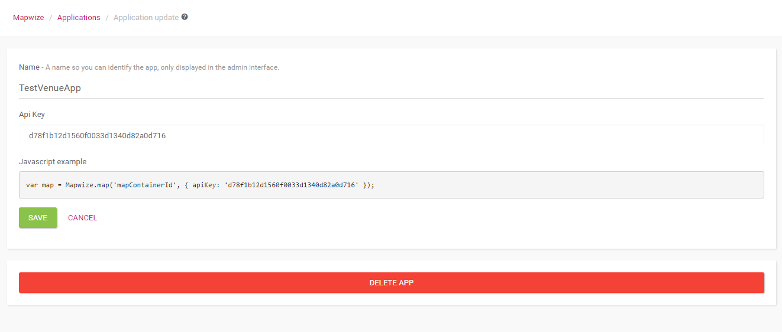

# Publish Venue

1. Go to the mapwize admin homepage and then enter the **Venue** menu.
2. Check Published to **yes.**



1. Hit the **SAVE** button.

Before We Begin The ServiceNow Labs

Pre-Requisites

Please follow this step before begin the next labs.

# MapWize UI Script

Before testing our UI Page, we need to import into ServiceNow the MapWize library and the css theme.

**NOTE: Create this steps using the Global Application.**

**Importing the MapWize library**

1. Navigate to **System UI > UI Scripts**
2. Hit the **New** button
3. Follow the form as shown below:

* Name: **MapwizeAll.**
* Script: Go to the following file <https://goo.gl/1lEaE7> and copy its contents into the Script field.
* Global: **true (checked)**
* Active: **true (checked)**
* Hit the **Submit** button

**Importing CSS theme**

1. Navigate to **Content Management > Style Sheets**
2. Hit the **New** button
3. Follow the form as shown below:

* Name: **Mapwize.**
* Style: <https://goo.gl/yMyi07>
* Type: **Local Style Sheet**
* Hit the **Submit** button

# Create Application

1. Navigate to **System Application > Applications**
2. Hit the **New** button
3. Select ***Create custom application*** and click **Create**
4. Follow the form as shown below:

* **Name:** Mapwize Integration
* Hit the Create button.

**NOTES:**

-You can also create your application using the studio.

-You can catch up to all the labs by importing the following repository:

<https://github.com/lfontanilla/ServiceNow_MapWize_Integration>

-After switching branch, you would have to 1st update your MapWize UI Pages CSS link to include the correct MapWize Style Sheet sys_id. After this, commit your changes and you should not have to do that again, just once per lab.

-If switching to Labs 1.4 or 1.5 then also import the following XML file: <https://goo.gl/cNoK66>

Lab Goal

Lab 1.2   
Create UI Page for the indoor map

Now that we have the MapWize side and library sorted.  
We can start development ServiceNow side in our application to get the Map Loading in our instance.

# Create System Properties Records

1. List System Properties, type in Filter navigator ***sys_properties.list***
2. Hit the **New** button
3. Fill the form **System Properties** (New Record) as shown below:

**Subfix**: routing.mapwize.accesskey

**Type**: string

**Value**: Access Key value for your Mapwize account.

1. Hit the **Submit** button.
2. Repeat the previous steps to complete all properties necessaries in the project.

|  |  |  |
| --- | --- | --- |
| Subfix | Type | Value |
| routing.mapwize.accesskey | String | Access Key value in your Mapwize account |
| routing.mapwize.apikey | String | API Key value in your Mapwize account |
| routing.mapwize.bounds.bottomright.lat | String | Initial Latitude value. |
| routing.mapwize.bounds.bottomright.long | String | Initial Longitude value. |
| routing.mapwize.bounds.topleft.lat | String | Final Latitude value. |
| routing.mapwize.bounds.topleft.long | String | Final Longitude value. |
| routing.mapwize.defaultcenterplace | String | Id Place sets the default center place in the indoor map. |
| routing.mapwize.applicationname | String | Application Name |

**NOTE**: show the correct bounds (We can use google maps to get the correct bounds).

# Create Script Include

We will reuse this script include in an Ajax call in our UI Pages to load properties and the location IDs from the records involved.

1. Navigate to **System UI > Script Includes**
2. Hit the **New** button
3. Follow the form as shown below:

* Name: **MapWizeAjaxHelper.**
* Client callable: **Checked.**
* Script: <https://goo.gl/ZgSS7w>
* Hit the **Submit** button.

**NOTE:** Change the values and property names according the name of your application, the bounds for your map and the id of the place you want the map to be centered on.

# Create UI Page.

1. Navigate to **System UI > UI Pages**
2. Hit the **New** button
3. Follow the form as shown below:

* Name: **MapWize.**
* HTML: [https://goo.gl/iE5hDz](https://goo.gl/iE5hDz%20)
* Client Script: <https://goo.gl/e0AyNH>
* Hit the **Submit** button.

**Note:** In the HTML content,change the link href sys_id value in line 3 with the sys_id of the new css file created before the labs**.**

After all these steps are completed your ui page should allow you to plot routes from the locations created in Mapwize.

# 

# Your screen should look something like this:

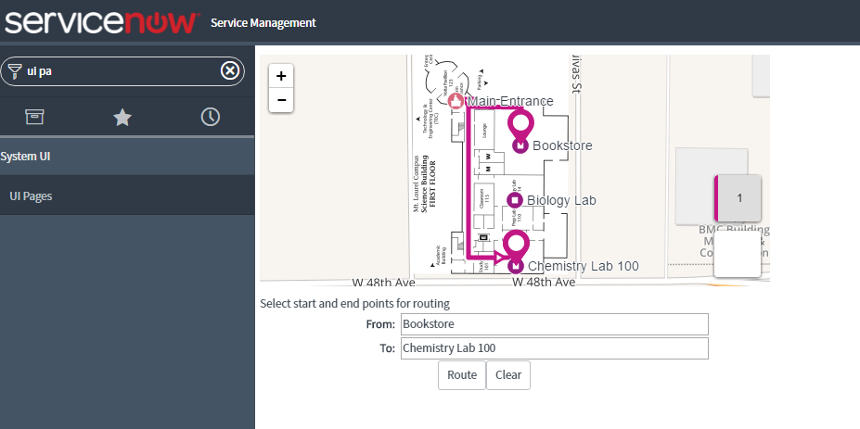

Lab Goal

Lab 1.3   
Create Module for the mobile indoor map

Now that we have a ui page with the MapWize integration working in our instance.  
We can create a modules (mobile) so users can trace routes on their mobile devices.

# Create UI Page to be loaded in the mobile homepage.

1. Navigate to **System UI > UI Pages**
2. Hit the **New** button
3. Follow the form as shown below:

* Name: **indoor_home_mobile.**
* HTML: <https://goo.gl/rtzR1C>
* Client Script: <https://goo.gl/jZytL6>
* Hit the **Submit** button.

**Note:** In the HTML content,change the link href sys_id value in line 3 with the sys_id of the new css file created before the labs**.**

# Create UI Macro to display the UI Page.

1. Navigate to **System UI > UI Macros**
2. Hit the **New** button
3. Follow the form as shown below:

* Name: **indoor_mobile.**
* XML: <https://goo.gl/Nc025G>
* Hit the **Submit** button.

**NOTE:** Replace line 3 with your application name.

# Create Application Menu (Mobile).

1. Navigate to **System Definition > Applications (Mobile)**
2. Hit the **New** button.
3. Follow the form as shown below:

* Title: **MapWize**
* Category: **Custom Application**
* Hit the **Submit** button.

# Create Mobile Module.

1. Navigate to **System Mobile UI > Mobile Modules**
2. Hit the **New** button.
3. Follow the form as shown below:

* Name: **MapName**
* Application menu: **MapWize**
* Path: **view/{API Name UI Macro}\***
* Hit the **Submit** button.

**NOTE:** Replace {API Name UI Macro}* to your API Name UI Macro created.

# Create Mobile Home Page Module.

1. Navigate to **System Mobile UI > Home Screen > Home Page Modules**
2. Hit the **New** button.
3. Follow the form as shown below:

* Title: **MapTitle**
* SubTitle: **Company**
* Module: **MapName**
* Icon (optional)
* Image (optional)
* Hit the **Submit** button.

After hitting the Mapwize icon, It should look something similar to this:

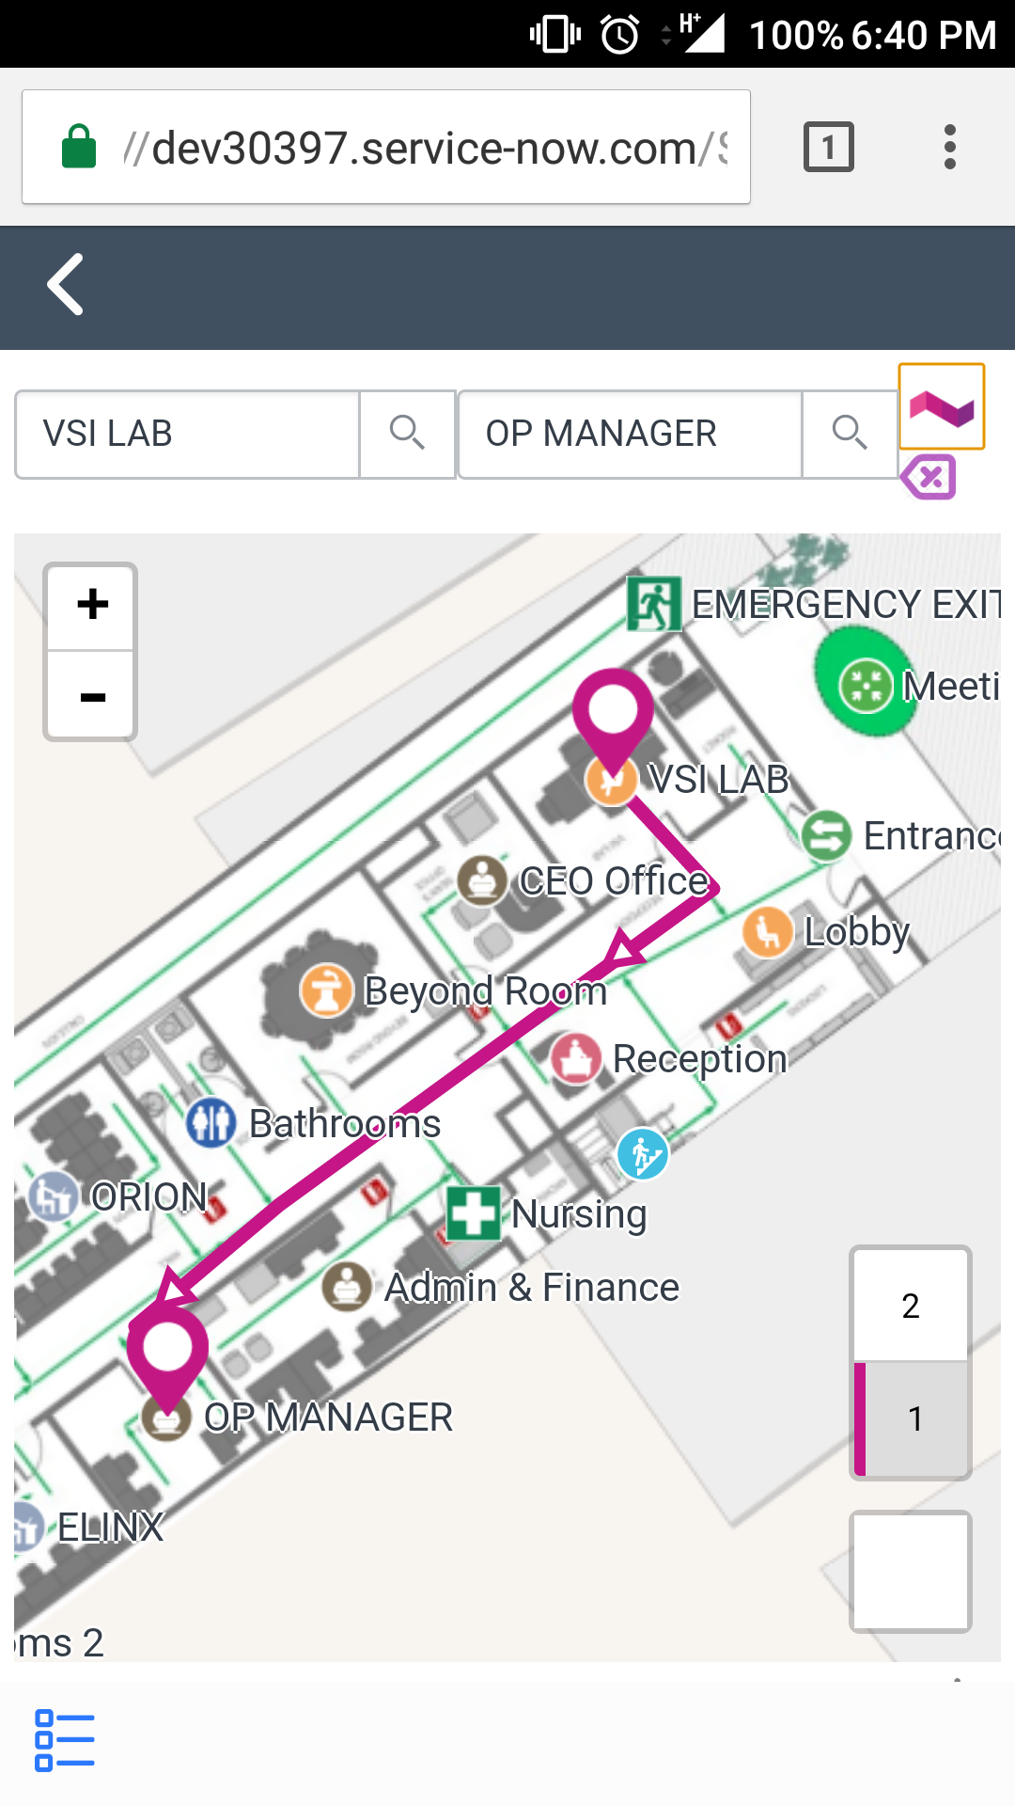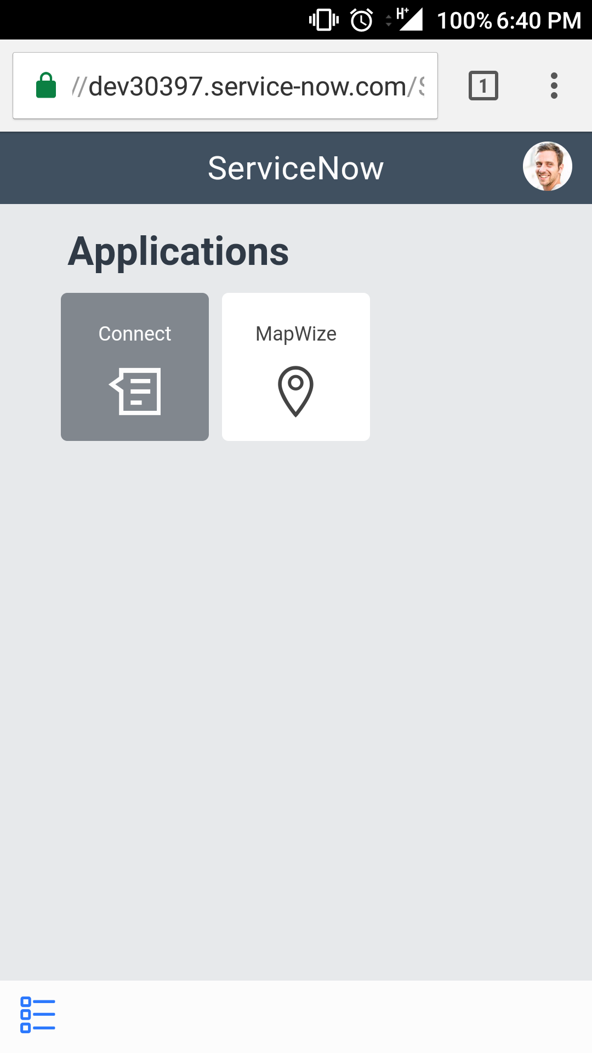

Some phone browsers force the desktop ui. You can always switch to ServiceNow mobile version by going to yourinstance.service-now.com/$m.do

Lab Goal

Lab 1.4   
Assign an indoor Location to a user

Now that we have a ui page with the MapWize integration working in our instance and we can use the integration from our mobile devices, we can try to extend the functionality to any scenarios that can apply.  
In this lab we will:   
1. Add a new field to the user record that will reference a location in the MapWize map. Add a Macro that will allow the user select an indoor location from the Map.  
2. Add a Macro to that field that will allow us to draw routes ­­­­­­from our user profile indoor location to another user’s.

# Create the Indoor locations table and MapWize field.

We could assign the Mapwize location id straight to a string field in the user record, but that would not be very user friendly as it will display a 32 char sys id. Let’s create a table to associate those IDs to a name that the user can relate to something in their building.

Let’s start with creating the table.

1. Navigate to **System Definition > Tables & Columns**
2. Hit the button **Create Table**
3. Fill in the form as shown below:

* Label: **indoor location.**

1. Fill in the Table columns tab as shown below:

* Column label: **Id Place**
* Type: **String**
* Column label: **Name Place**
* Type: **String**
* Display: **true**

1. Hit the **Submit** button.

Now that we have our table we have to fill it in with records, sadly MapWize is not developed enough to export all location names and their ids, so we would have to go about adding the info manually.

To enter a new record in our Indoor Locations table:

1. Go to MapWize (<https://www.mapwize.io/admin>)
2. Then enter your venue.
3. Then go to places.
4. There you will have to go to each of the places, hit the edit button and grab the ID, it should look like this (make a note of it):

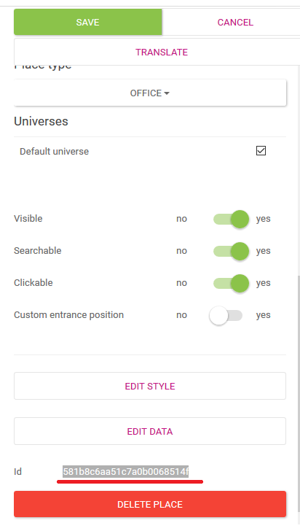

1. Then also make a note of the Place Name:

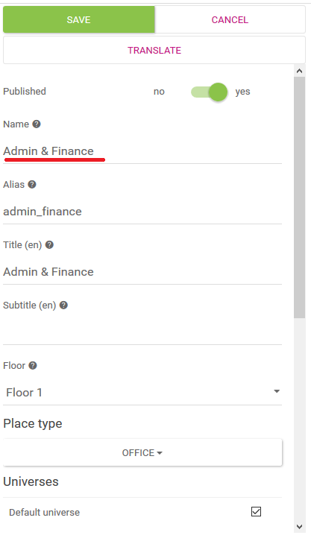

1. Now go to ServiceNow, and navigate to **Indoor Locations**
2. Hit the **New** button.
3. As Item ID and Place Name enter the respective value copied before.
4. Hit the **Submit** button.
5. Repeat steps 4 - 9 for each of the places in your MapWize indoor map.

An alternative to this last step is to use a new feature in Mapwize called export:

1. In your MapWize venue admin page, scroll all the way down to the export option.
2. Hit the Export Places as CSV button, it should generate a CSV file with the name of your venue:

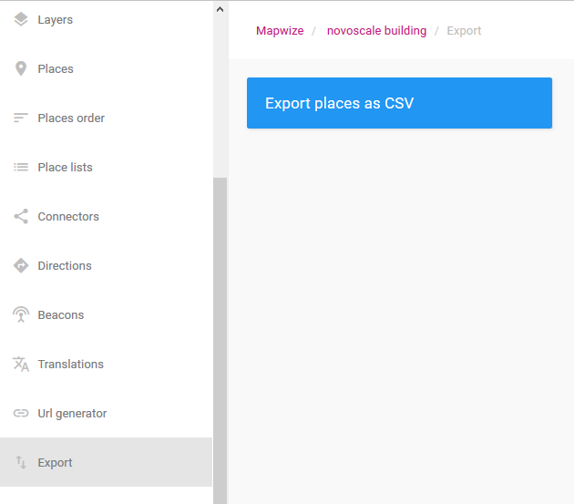

1. Change the extension of the downloaded file to csv, Then we can Import it via Load Data, Transform.
2. The following code can will bring the ID in a field map:

var str = source.u_id;

str = str.substr(1,24);

return str;

1. After trandforming we should have all indoor location values from MapWize filled in in our Indoor Location ServiceNow table:

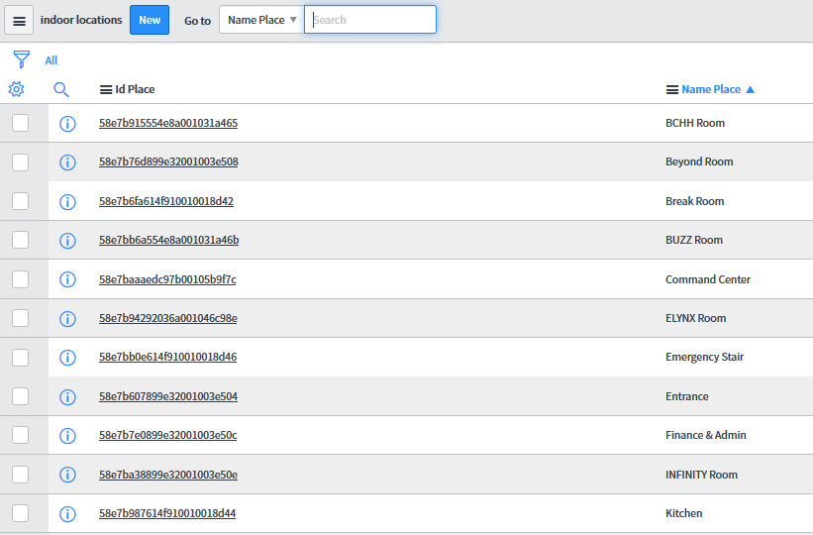

Now being able to reference the Indoor Locations from ServiceNow itself, let’s move on to create the MapWize field in the user record.

1. Navigate to the **Users** module.
2. Enter to any user record.
3. Right click the record and navigate to **Configure > Form Layout**
4. Fill in the **Create new field** section with the following values:

* Name: MapWize
* Type: Reference
* Table to reference: Indoor Location [u_indoor_location]

1. Hit the **Add** button.
2. Move the field to somewhere visible up top in the user form.
3. Hit the **Save** button.

Now by going to the user record and selecting a value for the MapWize field, we are selecting an indoor location for the user.

But it would be better if we could load the indoor map and select the location from the map itself. Let’s give the user form that capability.

1. Navigate to **System UI > UI Pages**
2. Hit the **New** button.
3. Fill in the New UI Page form with the following values:

* Name: **UserSetPoint**
* HTML: <https://goo.gl/sgOu87>
* Client Script: <https://goo.gl/A8RBJr>
* Hit the **Submit** button.

**Note:** In the HTML content,change the link href sys_id value in line 3 with the sys_id of the new css file created before the labs**.**

1. Navigate to **System UI > UI Macros**
2. Hit the **New** button.
3. Fill in the New Macro form with the following values:

* Name: **MapWizeApp**
* XML: <https://goo.gl/INZTTg>

1. Hit the **Submit** button.

**NOTE:** Change the GlideDialogWindow value to the name of your UI Page.

Now create the image that is going to be displayed for the macro for the user to click in:

1. Navigate to **System UI > Images**
2. Hit the **New** button.
3. Please fill in the form in the following manner:

* Category: General
* Name: LogoIndoorMap.png
* Image: C:\Users\lfontanilla\AppData\Local\Microsoft\Windows\INetCache\Content.Word\LogoMapWize.png (<https://goo.gl/hrTxiT>)
* Hit the **Update** button.

Now we need to link the Macro created to the MapWize field:

1. Navigate to any user record.
2. Right click the label of the MapWize field.
3. Select **Configure Dictionary**
4. If not in it already, switch to the advanced view by hitting on the Related Link.
5. In the Attributes field add **ref_contributions={your_application_name}_MapWizeApp**
6. Hit the **Update** button.

If everything went well, you should be able to see the Icon you uploaded there next to the MapWize field. When clicking on it you should see the Map popup and when selecting a location, it should autopopulate to the MapWize field.

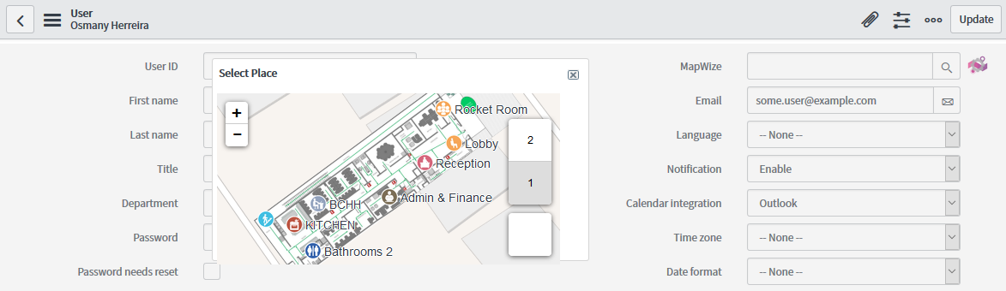

# Add another macro in the user form for routing to other user records.

If you have access to see another user profiles, if can come in handy to be able to draw routes from one user record to another.

Let’s add another macro right next to the one we just created so we can draw routes between the logged in user and the profile the user is currently watching, as long as both of them have indoor locations selected in their user record.

Create the UI Page:

1. Navigate to **System UI > UI Pages**
2. Hit the **New** button.
3. Fill in the New UI Page form with the following values:

* Name: **UserSetRoute**
* HTML**:** <https://goo.gl/o4bnCT>
* Client Script: <https://goo.gl/F9NWCj>
* Hit the **Submit** button.

**Note:** In the HTML content,change the link href sys_id value in line 3 with the sys_id of the new css file created before the labs**.**

1. Navigate to **System UI > UI Macros**
2. Hit the **New** button.
3. Fill in the New Macro form with the following values:

* Name: **MapWizeRouteApp**
* XML**:** <https://goo.gl/Y06cHv>

1. Hit the **Submit** button.

Now create the image that is going to be displayed for the macro for the user to click in:

1. Navigate to **System UI > Images**
2. Hit the **New** button.
3. Please fill in the form in the following manner:

* Category: General
* Name: indooricon.png
* Image:

 (<https://goo.gl/vtJHMC>)

* Hit the **Update** button.

Now we need to link the Macro created to the MapWize field:

1. Navigate to any user record.
2. Right click the label of the MapWize field.
3. Select **Configure Dictionary**
4. If not in it already, switch to the advanced view by hitting on the Related Link.
5. To the Attributes **ref_contributions** add **{your_application_name}_MapWizeRouteApp** it should end up looking like: **ref_contributions={your_application_name}_MapWizeApp; {your_application_name}_MapWizeRouteApp**
6. Hit the **Update** button.

If everything went well, you should be able to see the Icon you uploaded there next to the MapWize field. If you are logged in or impersonating a user that have an indoor location set up and hit the macro in the user profile of someone who also have an indoor location set up. Then a popup showing a route between the two indoor locations should display.

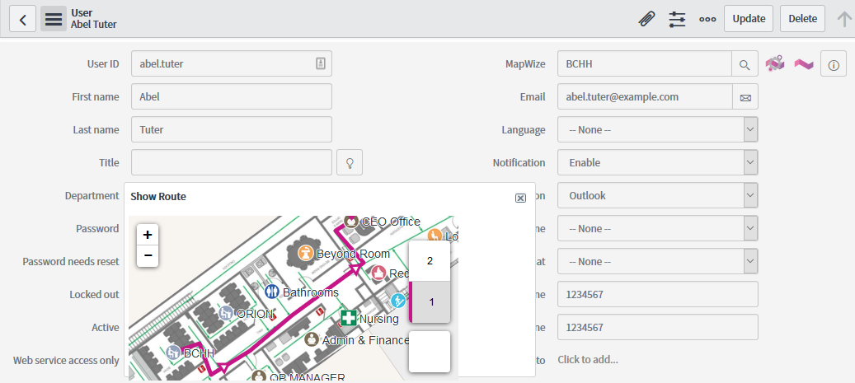

Lab Goal

Lab 1.5   
Route from a user to a CI in an Incident

Now that we have the users in our system linked to an indoor location in ServiceNow, we can leverage that development to show routes in any number of scenarios.

In this lab we will add a Macro in the incident form that will allow the user assigned to an Incident to see the route that goes right to the Configuration Item.

1. Add Macros just like we did for the user form, this time for the Configuration Item form, so we can set Indoor locations for all Cis that may need it.
2. Add a Macro to the Incident record, so we can trace routes from the assigned user to the CI.

# Create the Indoor Location field in the cmdb_ci table.

1. Navigate to **cmdb_ci.do** in the app navigator.
2. Right click the record and navigate to **Configure > Form Layout**
3. Fill in the **Create new field** section with the following values:

* Name: Indoor Location
* Type: Reference
* Table to reference: Indoor Location [u_indoor_location]

1. Hit the **Add** button.
2. Move the field to somewhere visible up top in the user form.
3. Hit the **Save** button.

Now by going to any Configuration Item record and selecting a value for the Indoor Location field, we are selecting an indoor location for the CI.

But it would be better if we could load the indoor map and select the location from the map itself. Let’s give the CI form that capability.

First create the UI Page that will display the map for selecting the location, then the macro that will represent a button:

Let’s start with the UI Page called **MapWizeCI_app**

1. Navigate to **System UI > UI Pages**
2. Hit the **New** button.
3. Fill in the New UI Page form with the following values:

* Name: MapWizeCI_app
* HTML: [https://goo.gl/KPfsgN](https://goo.gl/KPfsgN%20)
* Client Script: <https://goo.gl/6MBzsW>
* Hit the **Submit** button.

Then move on to create the macro that the user will click to show up the Location Selection Map.

1. Navigate to **System UI > UI Macros**
2. Hit the **New** button.
3. Fill in the New Macro form with the following values:

* Name: MapWizeCI_app
* XML: <https://goo.gl/Om0fyt>

1. Hit the **Submit** button.

Remember that in line 12 In the macro we need to replace the app + ui page name combo for our own app name + MapWizeCI_app

We are reusing the image we created for the Macro in the user record, so no new image is necessary.

Now we need to link the Macro created to the Indoor Location field:

1. Navigate to any CI record.
2. Right click the label of the MapWize field.
3. Select **Configure Dictionary**
4. If not in it already, switch to the advanced view by hitting on the Related Link.
5. In the Attributes field add **ref_contributions=MapWizeCI_app**
6. Hit the **Update** button.

If everything went well, you should be able to see the MapWize Icon next to the Indoor Location field. When clicking on it you should see the Map popup and when selecting a location, it should autopopulate to the Indoor Location field.

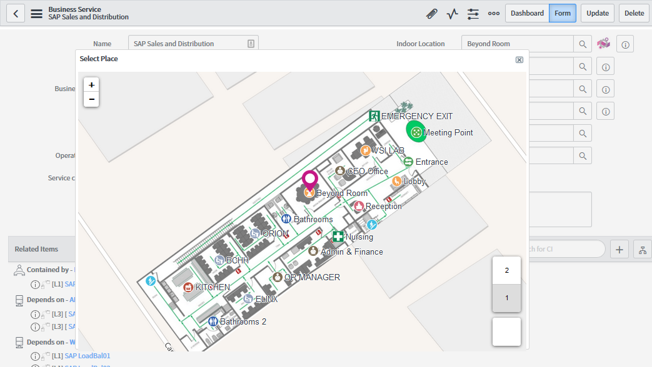

# Add a macro in the incident form for routing from the assigned To indoor location to the CI’s indoor location.

Now that we can set up indoor locations to the CIs, lets complete the requirement and add our Macro so we can draw routes between the Indoor Location of the Assigned to field to the Indoor Location of the CI in an Incident record.

Let’s add the macro in the Configuration Item field of the Incident record, so as long as both The Assigned To field and the CI field have indoor locations assigned, then we will be able to draw a route between them.

The Macro we are creating invokes a UI Page called **MapWizeRouteCI**So, let’s go ahead and create the UI Page:

1. Navigate to **System UI > UI Pages**
2. Hit the **New** button.
3. Fill in the New UI Page form with the following values:

* Name: MapWizeRouteCI
* HTML: <https://goo.gl/mjyABJ>
* Client Script: <https://goo.gl/JoCnDr>
* Hit the **Submit** button.

Now we need to link the Macro created to the Configuration Item field:

1. Navigate to any Incident record.
2. Right click the label of the Configuration Item field.
3. Select **Configure Dictionary**
4. If not in it already, switch to the advanced view by hitting on the Related Link.
5. To the Attributes **ref_contributions** add **MapWizeRouteCI** it should end up looking like: **ref_contributions=MapWizeRouteCI**
6. Hit the **Update** button.

Now let’s create the macro:

1. Navigate to **System UI > UI Macros**
2. Hit the **New** button.
3. Fill in the New Macro form with the following values:

* Name: **MApWizeRouteCI_app**
* XML: <https://goo.gl/diAG3u>

1. Hit the **Submit** button.

The image that is going to be displayed for the macro we already created in a previous step, if not then here are the steps again:

1. Navigate to **System UI > Images**
2. Hit the **New** button.
3. Please fill in the form in the following manner:

* Category: General
* Name: indooricon.png
* Image:



* Hit the **Update** button.

If everything went well, you should be able to see the Icon you uploaded there next to the Configuration Item field.

So if you are looking at an Incident with a Configuration Item and Assigned To field values that both have Indoor Locations set up, hitting the Macro should display a route between the Assigned To and the CI.

Just like in the image below:

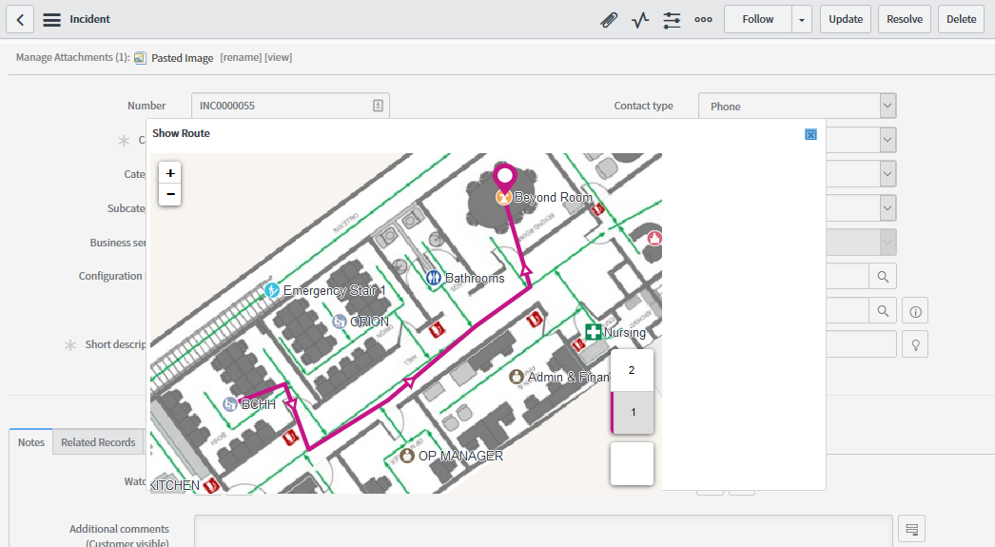

After that we can extend the functionality as we please. Maybe auto shoring the route popup when a fulfilment catalog task goes to state in progress, the possibilities are numerous.